**Name:محمد ياسر اسماعيل مصلحي**

**b.n:831**

**sec :38**

**group :7**

**topic : artificial intelligence**

# **application brief: I choose this topic (artificial intelligence) because it is the future and the next step in the technology and it is very important in many fields engineering ,medicine ,agriculture…….**

# **I think any country want to be great it should help their people to learn more about aI**

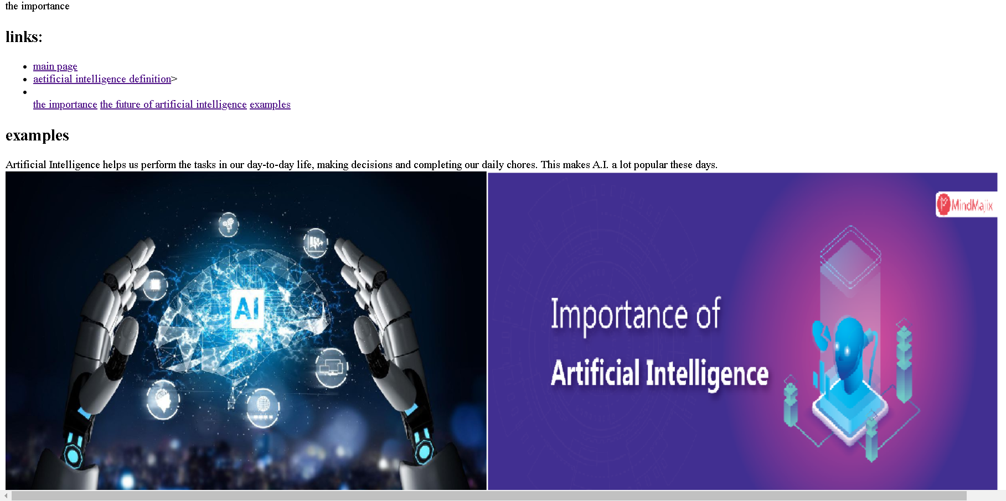

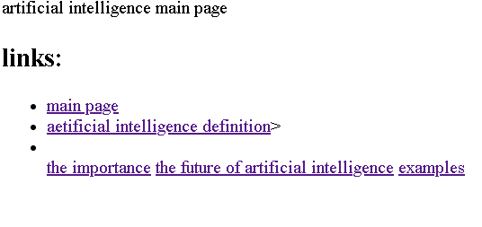

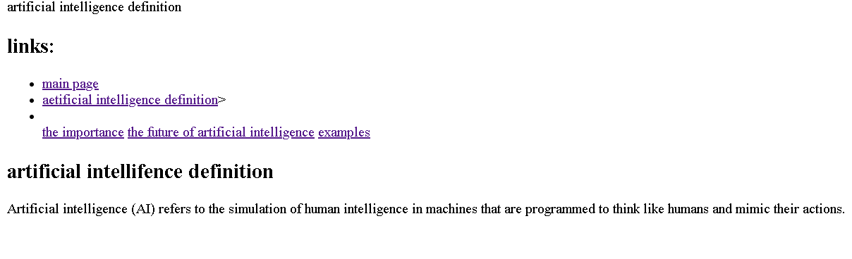

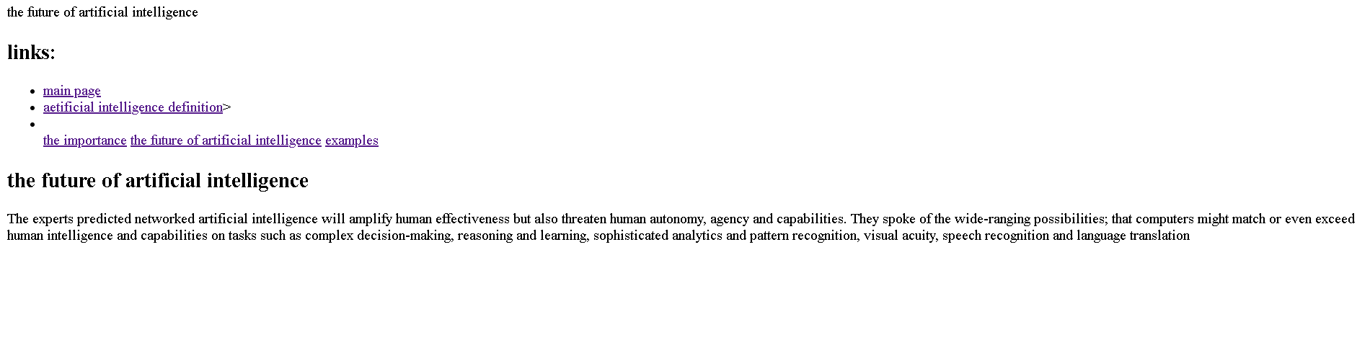

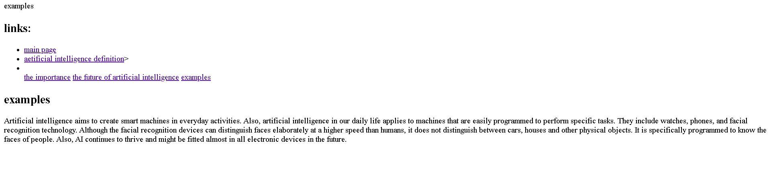

**Source code**

